CPR for Adults
Scene is safe!
C-CIRCULATION (3 steps):
- Check responsiveness and for breathing – “shake and shout” or if trauma suspected “touch and talk” – look for chest rise – if no response or breathing or abnormal breathing go to next step
- Call for nearby help – Call a Code Blue if in hospital and an defibrillator or if out of hospital Call 9-1-1
- a. Check Circulation- by palpating a carotid/femoral pulse (within 10
seconds). If no definite pulse within 10 seconds, then, begin chest
compressions.
- If a definite pulse is felt, then check the breathing – if abnormal (absent or gasps) give 1 breath every 6 seconds or 10 breaths/minute. Recheck pulse every 2 minutes or 5 cycles. If it is normal breathing with a pulse, monitor until help arrives or if opioid overdose is suspected, give naloxone if available.
- If no pulse - place the patient on a firm surface with the torso about the level of the rescuer’s knees.
- Provide - CIRCULATION w/chest compressions and ventilations
(30:2) for at least 100-120 compressions per minute, “hard and fast”,
at least 2 inches deep (not further) with minimal interruptions. Allow
for complete recoil of the chest after each compression.

A-AIRWAY: Open the AIRWAY using head-tilt-chin lift, if trauma suspected, then use jaw thrust method. Even if trauma is suspected and you are the only rescuer available, then open the airway using head-tilt-chin lift.

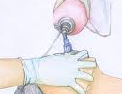
B- BREATHING: Assessment of this was done in step one - Provide BREATHING (2 breaths) allowing the chest to rise each time, give each breath over 1 second. Avoid too little or too many ventilations. If the breath does not go in, reposition the head with a head-tilt-chin lift and attempt to deliver 2 breaths. Utilizing a bag-valve-mask (BVM) requires a good seal – E-C method, E with 3 fingers along jawbone and C with thumb and forefinger on the mask.

D-DEFIBRILLATE (4 steps): (Use AED as soon as it is available)
- Turn on AED (Automated External Defibrillator)
- Connect to pt – connect patches to patient following diagram on the patches
- Clear pt to analyze - Checks for a shockable rhythm: (Pulseless Ventricular Tachycardia [V. Tach.] or Ventricular Fibrillation [V. Fib.]),
- Clear pt to Shock 1X at 120-200J (biphasic) or 360J (monophasic) – Chant “I’m clear, you’re clear, we’re all clear!!!” – return to CPR for 2 min – if no shock advised – CPR for 2 minutes and recheck AED – cont CPR for 2 min and recheck AED
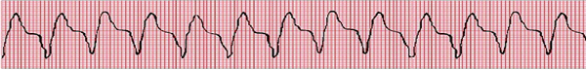
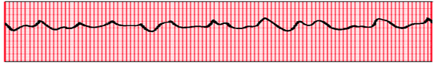

- POWER ON the AED (voice prompting will guide in all other steps)
- ATTACH the electrode pads to the patient
  - Can now be used on infants through adults
  - Use adult pads for everyone 8 years and above
  - Use child pads and for children 0-8 years old
  - Can use adult pads and voltage on all patients if pediatric patches/voltage is not available. – May be able to move a bra instead of remove a bra to put patches on a female patient.
  - Peel the backing away from the electrode pads
  - If the patient’s chest is hairy, the pads may not stick
  - If the patient is wet, make sure you dry the chest area
  - Avoid medication patches and implanted devices – but do not delay attaching electrodes for this reason.
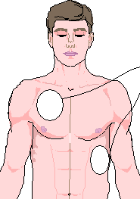
- ATTACH the connecting cables to the AED box, some may be preconnected
- Listen to the prompts!
- Clear the patient and allow the AED to ANALYZE the rhythm
  - Do not touch the patient or allow anyone else to touch the patient
  - You may need to push a button, or it may be automatic after a verbal prompt
- SHOCK ADVISED or NO SHOCK ADVISED will be indicated
  - If a shock is advised, then the AED will charge
  - Clear the patient: “I’m clear, you’re clear, everyone’s clear!”
  - Push the SHOCK button – purpose is to eliminate the rhythm
  - If no shock advised, skip directly to number 6.
- Resume CPR beginning with chest compressions
  - Do not remove the pads
  - Do not shut off the AED
  - After 2 minutes (5 cycles of compressions to ventilations), then the AED will prompt to reanalyze the rhythm.
Note: as the patient is smaller in size, the AED pad placement is best as Anterior/ Posterior.

CPR for Children (1 Year to Puberty)
Puberty = Female-breast development, Male-arm, facial, or chest hair.
Scene is Safe!
C-CIRCULATION (3 steps):
- Check responsiveness and for breathing – “shake and shout” or if trauma suspected “touch and talk” – look for chest rise – if no response or no breathing or abnormal breathing go to next step
- Call a Code Blue (9-1-1) if witnessed collapse/wait and call after 5 cycles of CPR if not witnessed (found unresponsive).
- a. Check CIRCULATION - by palpating a carotid/femoral pulse (within
10 seconds). If no pulse or < 60 bpm, begin chest compressions. If a
pulse > 60bpm is felt, then give 1 breath every 2-3 seconds.
Recheck pulse every 2 minutes or 5 cycles. Place on a firm surface.
- Provide - CIRCULATION w/chest compressions and ventilations (30:2-for 1 person /15:2-for 2 person) for at least 100-120 compressions per minute, “hard and fast”, at least 1/3 depth of chest, about 2 inches. May use 1 or 2 hands for CPR. Allow for complete recoil of the chest after each compression. Do not have any pauses greater than 10 seconds without returning to CPR.
A-AIRWAY: Open the AIRWAY using head-tilt-chin lift, if trauma suspected, then use jaw thrust method. Even if trauma suspected and you are the only rescuer available, then open the airway using head-tilt-chin lift.

B- BREATHING: Assessment of this was done in step one - Provide BREATHING (2 breaths) allowing the chest to rise each time, give each breath over 1 second. If the breath does not go in, reposition the head by head-tilt-chin lift and attempt to deliver 2 breaths. Utilizing a bag-valve-mask (BVM) requires a good seal – E-C method, E with 3 fingers along jawbone and C with thumb and forefinger on the mask.
D-DEFIBRILLATE (4 steps):
- Turn on AED (Automated External Defibrillator)
- Connect to pt – connect patches to patient following diagram on patches
- Clear pt to analyze - Checks for a shockable rhythm: (Pulseless Ventricular Tachycardia [V. Tach.] or Ventricular Fibrillation [V. Fib.]),
- Clear pt to Shock 1X at 120-200J (biphasic) or 360J (monophasic) - Chant “I’m clear, you’re clear, we’re all clear!!!”

CPR for Infants (up to 1 year of age)

C-CIRCULATION (3 steps):
- Check responsiveness and for breathing – tap the foot and look for chest rise – if no response or breathing or abnormal breathing go to next step
- Call a Code Blue (9-1-1) if witnessed collapse/wait and call after 5 cycles of CPR if not witnessed (found unresponsive).
- a. Check CIRCULATION - by palpating a brachial pulse (two fingers on the inside of upper arm between the shoulder and the elbow) within 10 seconds. If no pulse or < 60 bpm, begin chest compressions. If a pulse is felt > 60 bpm, then give 1 breath every 2-3 seconds. Recheck pulse every 2 minutes or 5 cycles. Place on a firm surface.
b. Provide - CIRCULATION w/chest compressions and ventilations
(30:2-for 1 person /15:2-for 2 person) for at least 100-120 compressions
per minute, “hard and fast”, at least 1/3 depth of chest same as a child.
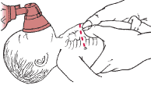
Use the heal of one hand for compressions or the 2 thumb-encircled hands technique for compressions, one finger below the nipple line for or the
two thumb-encircling hands technique. No longer use the 2 fingers for chest compressions.

A-AIRWAY: Open the AIRWAY using head-tilt-chin lift to a neutral position
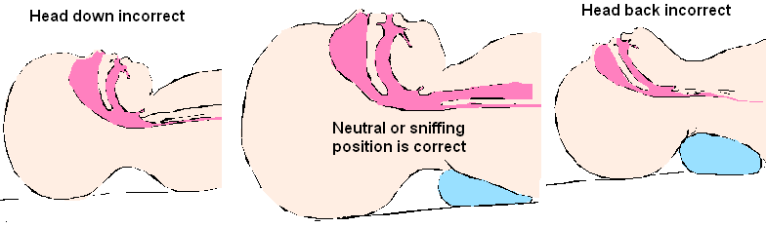
B- BREATHING: Assessment of this was done in step one - Provide 2 breaths (puffs) allowing the chest to rise. Provide breaths by mouth of the rescuer to-mouth-and-nose of the infant or with bag-valve-mask. If the breath does not go in, reposition the head by head-tilt-chin lift and attempt to deliver the 2 breaths.

D-DEFIBRILLATE ( 4 steps):
- Turn on AED (Automated External Defibrillator)
- Connect to pt – connect patches to patient following diagram on patches
- Clear pt to analyze - Checks for a shockable rhythm: (Pulseless Ventricular Tachycardia [V. Tach.] or Ventricular Fibrillation [V. Fib.]),
- Clear pt to Shock 1X at 120-200J (biphasic) or 360J (monophasic)

Relief of Choking
Signs of Foreign Body Airway Obstruction:  - Weak or absence of cough  - Unable to speak  - Change in color (cyanosis)  - Altered mental status  - Apnea (no breathing)  Rescuer actions:  - Ask the patient if he or she is choking. If the patient nods yes and cannot talk, severe airway obstruction is present, and you must activate the emergency response system | Mild Airway Obstruction:  Principles of when to act:  -As long as good air exchange continues,  encourage the patient to continue  spontaneous coughing and breathing  efforts.  -Do not interfere with the patient’s own  attempts to expel the foreign body, but stay  with the patient and monitor his/her  condition.  -If this persists, then activate the emergency  response system.  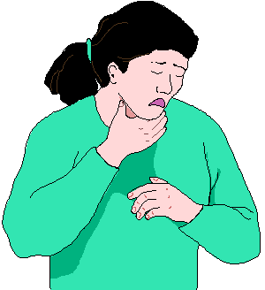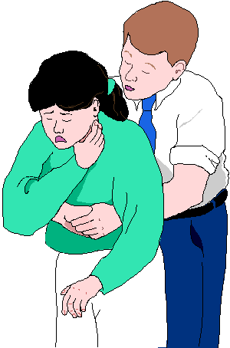  Universal Choking Sign
- Alternate between 5 back blows (slaps) and 5 abdominal thrusts.
- Stand or kneel behind the patient and wrap your arms around the patient’s waist.
- Make a fist with one hand.
- Place the thumb side of your fist against the patient’s abdomen, in the midline, slightly above the navel and well below the breastbone.
- Grasp your fist with your other hand and press your fist into the patient’s abdomen with a quick upward thrust 5 times, then repeat 5 back blows (slaps)
- If the patient becomes unresponsive, lay the patient on a firm surface, call 911, and begin the steps of CPR + add the step of looking for a foreign object in the mouth. And remove it if found.
- DO NOT PERFORM BLIND FINGER SWEEPS ON ANYONE OF ANY AGE.
- For infants when responsive, provide 5 back blows and then 5 chest compressions using the 2-finger method. When unresponsive, treat like infant CPR with 1 extra step. Look for a foreign object in the mouth when opening the airway and giving breaths.
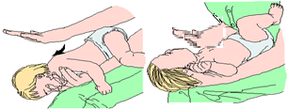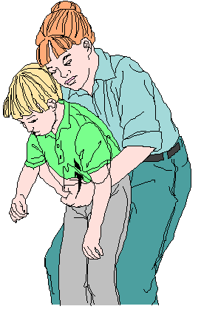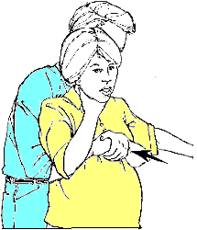
- If a patient is pregnant or too large to wrap your arms around the stomach, one would give 5 back blows (slaps) and then push on the chest 5 times to relieve the obstruction. This can be done behind the patient or have the patient stand against the wall or lie down and perform pushing on the chest 5 times until the patient becomes unresponsive, then 911 is contacted and CPR is performed.

Special Notes:
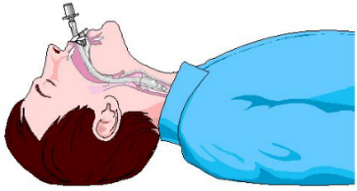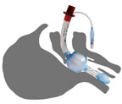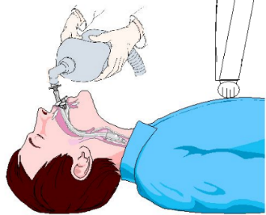
- Once an advanced airway is in place, chest compressions can be continuous (at a rate of at least 100-120 per minute) and no longer need to be cycled with ventilations. A person can ventilate the patient with a bag valve mask at 1 breath every 6 sec (about 10 breaths per minute).
- When calling 9-1-1, it is important to know where you are and making sure help can find you (providing an address, street location, building name, best door to come in, etc. is important).
- If a barrier device is not available for airway management, then move to chest compressions, only until advanced help has arrived and can safely take over care.
- Best chances for to know boundaries is for everyone to know their limitations and let the team leader know early on.
- Best way of success in running a team is for everyone to know their role.
- Post–Cardiac Arrest Care and Education, Implementation, and Teams (responsibilities, communication, effectiveness, and leadership roles).
- Recognition of Stroke in Children – 40,000 children worldwide experience stroke: Focal Signs and symptoms: Hemiparesis, Limb weakness, Facial droop, Altered sensation, Visual disturbance, Speech disturbance – General Signs and symptoms: Altered mental status, seizure, headache, ataxia, vertigo/dizziness, nausea/vomiting.
- F.A.S.T. – Facial drooping, arm weakness, speech difficulties, time to call 911.
- Call 911 – if a person has a seizure for the first time, seizures lasting more than 5 min, seizures in water or trauma or choking or difficult breathing or if younger than 6 months or pregnant women or if not returning to normal in 5-10 minutes. Nothing by mouth and put them in the recovery position.
- Opioid overdose – if a pulse is present and breathing is abnormal – may try to give naloxone if available. If no pulse, CPR takes precedence.
- Incorporating immediate and delayed debriefing may identify opportunities for improvement. Children and infants need follow up care throughout first year after.
- CPR can be traumatic for everyone involved and should encourage people to seek treatment and counsel expressing their concerns – sad, angry, playing it over and over in your mind.

